The gearing
- What is required for the gearing section?
  - There is a pendulum on an ‘A’ frame body with an axle on the top.
  - The pendulum is needed to move in a forward direction based on the movements of the pendulum, but the pendulum’s momentum is not the driver of the car.
  - A gear box that works in one direction that moves the wheel axle is required.
- Problem:
  - The issue is in developing a gear that will take the rotation of the pendulum axle or the pendulum itself and translating this into rotations of the rear wheels.
  - The pendulum cannot be directly connected to the wheels itself otherwise it will follow the back and forth sinusoidal movements of the pendulum.
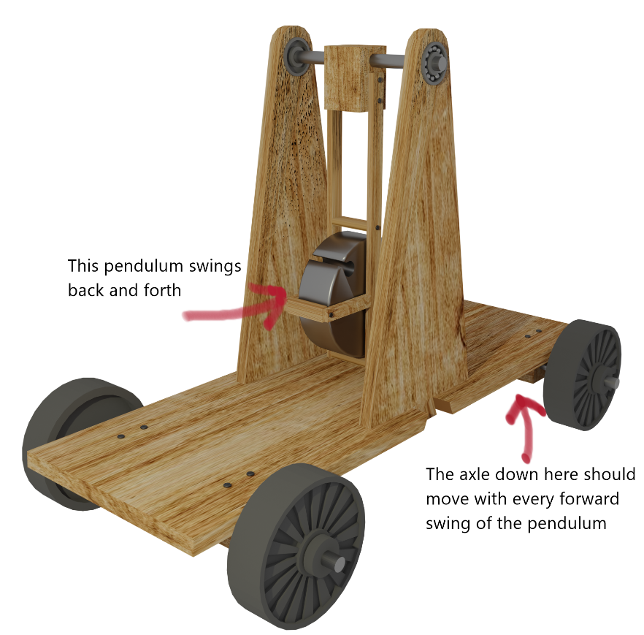
  - Traditional gears work in both directions but the design for this system needs to work in only one direction. How can you develop a one-way gear?
  - If using gears, would multiple gears be used to take energy from the top to the bottom? Or could we use a pulley instead?
- Ideas and concepts:
  - The initial idea of using a pulley against several gears, the issue with this design was the large gear and that it could possibly not work in one direction.
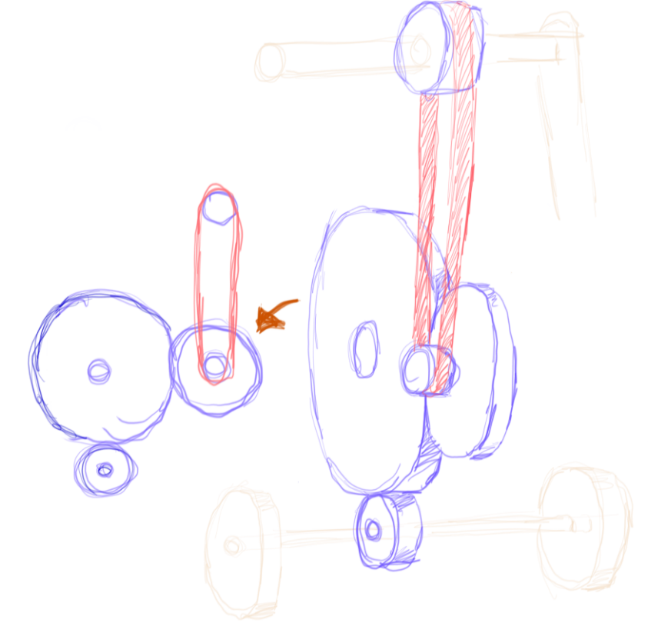
Figure 1 - Gears to use the movement of the pendulum for axle movements
  - To overcome the problem of backwards motion, a ratchet gear was proposed, the figure below shows what the idea was based on. This has slanted gears that all faced a certain direction, the gears would spin only in one direction but not the other. The only problem was, it will lock up if the pendulum swings backwards.
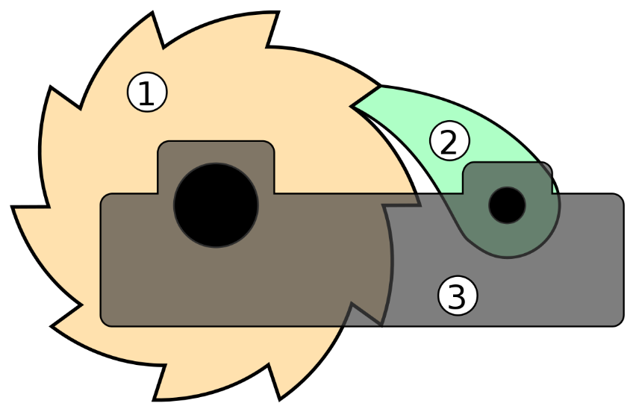
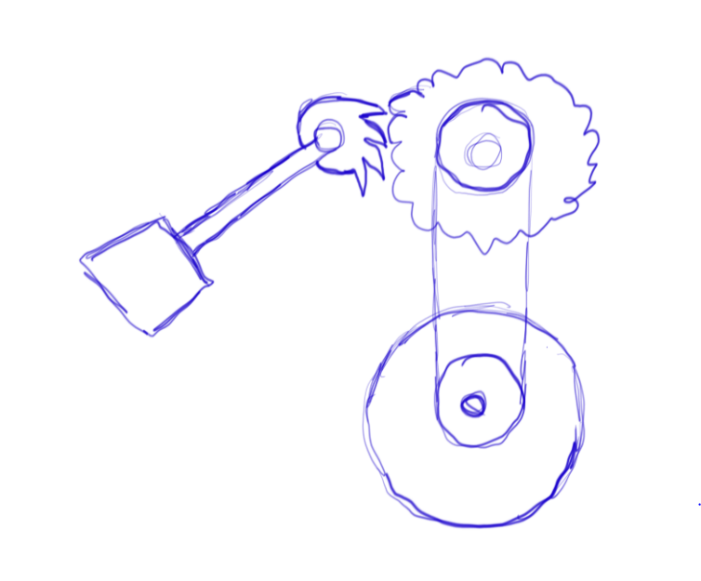
Figure 2 - Initial idea of the ratchet and the pendulum
  - To allow for the gear to spin backwards without locking up, two gears were introduced. This design will have the gears spinning backwards but it will have minimal effects when compared to the designs above. When it spins forwards, it will push the second gear and allow for gear rotation, when going backwards, the gear will roll over the previous gear and should have very minimal rotations.
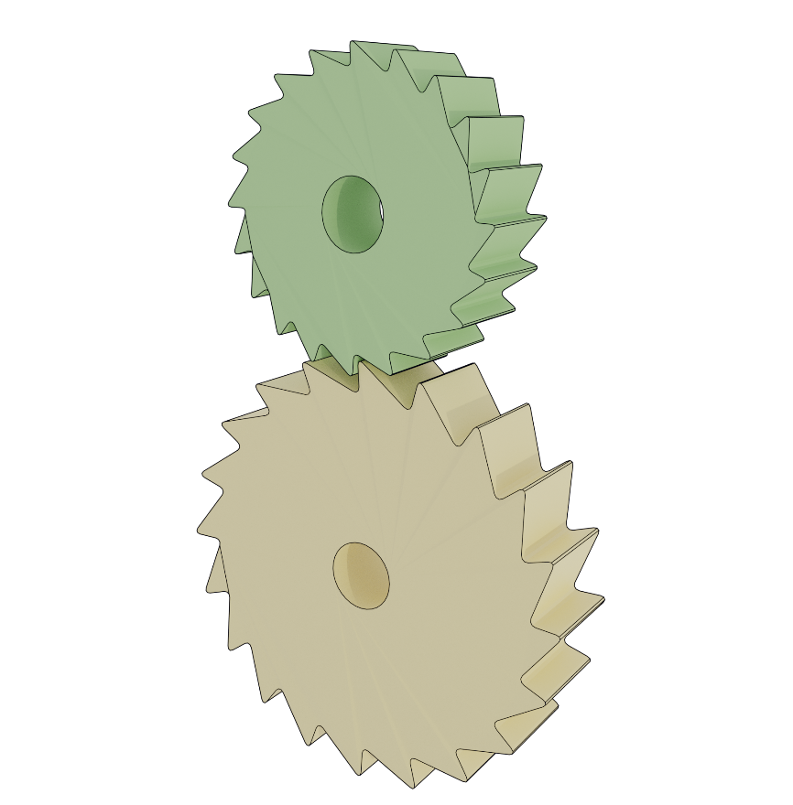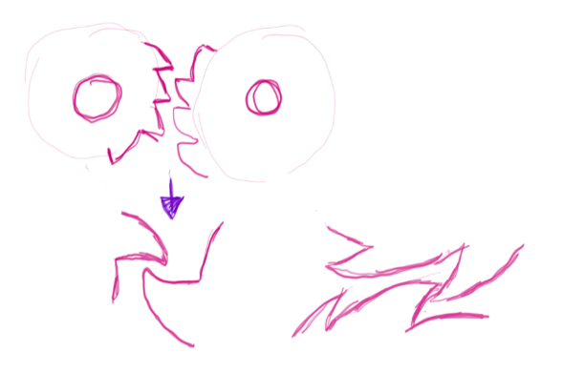
Figure 3 - Profile concept for ratchet gears

  - The gears on the car design. The top gear is larger and should give the smaller yellow gear more torque and speed. The red band is used to spin the black gear directly below. The purpose of the two black gears is to move the axle without having to attach the pulley directly to the axle. The issue here is that the car will move in the wrong direction, when the swing moves to the right, the green gears will spin anti-clockwise and due to the wheel configuration, it will move the car backwards. The reason the second back gear exists is to prevent the two pulleys from overlapping the same gear shaft. A third gear may be needed. The long pulley from the yellow gear could be attached directly to the axle from here.
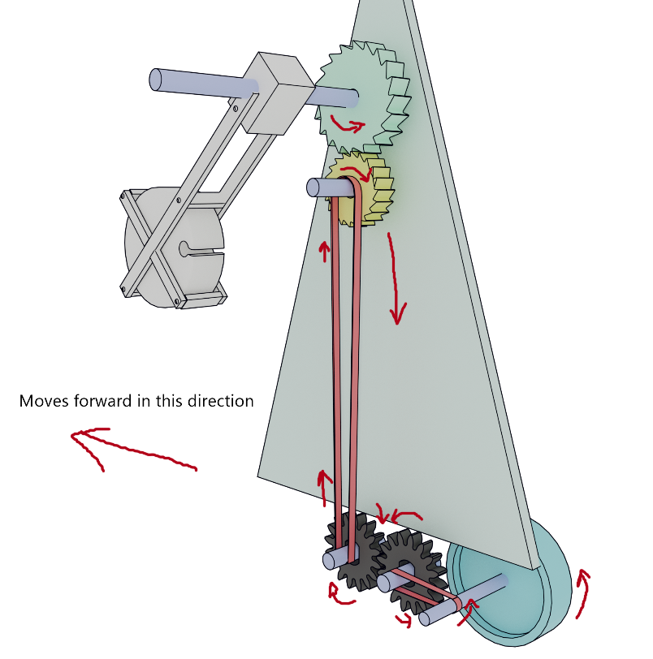
Figure 4 - Gears attached to the car

